A PROJECT REPORT ON

HOTEL & AIRBNB BOOKING PRICING & OCCUPANCY ANALYTICS USING EXCEL, SQL AND POWER BI

Submitted in partial fulfilment of the requirements for the award of the degree of
BACHELOR OF TECHNOLOGY
in
COMPUTER SCIENCE AND ENGINEERING

Submitted by
Sukhwinder Singh
(University Roll No.: 2419411)

Under the Guidance of
Pawan Saini

DEPARTMENT OF COMPUTER SCIENCE AND ENGINEERING
CGC University Mohali
July, 2026

ABSTRACT
The hospitality industry generates continuous booking and transactional data through hotels and Airbnb-style properties, yet organisations often struggle to convert this raw data into decisions that improve occupancy, pricing, and customer experience. This project presents an end-to-end analytics solution built on a hospitality booking dataset comprising seven related tables — bookings, customers, properties, hotel details, Airbnb details, payments, and reviews — using Microsoft Excel, MySQL, and Power BI.
The dataset was first cleaned in Excel to resolve missing values, duplicates, inconsistent categories, and formatting errors. The cleaned data was imported into MySQL Workbench, where a relational database was built and more than twenty analytical SQL queries were executed covering revenue, bookings, customers, properties, payments, and reviews. Finally, the data was modelled in Power BI, DAX measures were defined for key KPIs, and a two-page interactive dashboard was designed with slicers and navigation buttons.
The resulting solution converts disorganised booking records into a coherent decision-support system, revealing high-revenue cities, hotel-versus-Airbnb performance, seasonal booking patterns, preferred room types, payment preferences, and customer satisfaction levels. The project also strengthened practical skills in data cleaning, relational database design, SQL querying, and dashboard design.

TABLE OF CONTENTS

1. Cover Page 1
2. Abstract 2
3. Table of Contents 3
4. List of Figures 5
5. List of Tables 6
6. Introduction 7
7. Literature Review 7
8. Problem Statement 8
9. Objectives 9
10. Scope of the Project 9
11. Project Methodology 10
12. Tools and Technologies 10
13. Dataset Description 11
14. Data Cleaning and Preprocessing 12
15. Excel Dashboard Development 13
16. SQL Database Implementation 14
17. SQL Analysis 15
18. Power BI Data Modeling 16
19. DAX Measures 17
20. Dashboard Development 18
21. Dashboard Explanation 18
22. Business Insights 20
23. Challenges Faced and Solutions 21
24. Skills Learned 21
25. Conclusion 22
26. Future Scope 23
27. References 23

LIST OF FIGURES

Fig 16.1: Excel Data Cleaning Process 15
Fig 17.1: Excel Dashboard 17
Fig 18.1: MySQL Workbench – Database Creation 17
Fig 20.1: Power BI Data Model 18
Fig 23.1: Dashboard Page 1 – Executive Overview 20
Fig 23.2: Dashboard Page 2 – Customer & Property Insights 20

LIST OF TABLES

Table 14.1: Tools and Technologies Used 13
Table 15.1: Dataset Tables and Descriptions 14
Table 15.2: Relationship Between Tables 15
Table 16.1: Key Data Cleaning Challenges and Solutions 16
Table 19.1: SQL Implementation Summary 18
Table 21.1: DAX Measures Summary 19
Table 24.1: Summary of Business Insights 21
Table 27.1: Final Project Summary 23

8. INTRODUCTION
Hotels and Airbnb-style properties generate large volumes of booking, customer, payment, and review data. Individually these records are of limited use; organised and analysed together, they reveal patterns in pricing, occupancy, and customer behaviour that support better business decisions. In practice, this data is usually scattered across separate, inconsistently maintained records, and must be cleaned and structured before any reliable analysis is possible.
This project undertakes a complete analysis of a hospitality booking dataset organised into seven related tables — bookings, customers, properties, hotel details, Airbnb details, payments, and reviews. The work followed a three-stage pipeline: the dataset was first cleaned in Microsoft Excel, then loaded into a MySQL relational database where analytical SQL queries were executed, and finally modelled in Power BI to produce a two-page interactive dashboard with KPI cards, charts, slicers, and navigation buttons. This mirrors how business intelligence is practised in real organisations — verifying data quality first, structuring it relationally, and only then visualising it for decision-making.
Each stage of this pipeline was allowed to mature fully before the next began: SQL queries were written only after the data had been cleaned and validated, and dashboard visuals were built only after the underlying relationships had been verified. This sequencing, followed consistently throughout the project, is what allows every figure on the final dashboard to be traced back to a clean, validated source.
The remainder of this report follows this progression: background and objectives, methodology and tools, the dataset and its cleaning, the SQL and Power BI implementation, the resulting business insights, and a final reflection on challenges, skills gained, and future scope.

9. LITERATURE REVIEW
Business intelligence converts raw operational data into information that supports decision-making. Early hospitality reporting relied on manually compiled, static spreadsheets; as reservation systems digitised, data volumes grew faster than the tools used to interpret them, leaving many businesses data-rich but insight-poor. Self-service BI platforms such as Power BI addressed this gap by letting analysts build interactive reports without depending on dedicated database teams.
Spreadsheet tools remain central to the early stages of any analytics workflow: Excel's duplicate-removal, text-cleaning, and Pivot Table features make it a practical first step for inspecting data quality before it reaches a database. Data-quality literature consistently notes that the accuracy of downstream analysis, whether via SQL or a BI dashboard, depends heavily on the rigour applied at this initial stage, since inconsistent labelling or duplicate transactions can distort aggregate figures such as total revenue.
Relational database theory — organising data into related tables joined by keys — underpins most analytical systems, with SQL serving as the standard language for expressing joins, filters, and aggregations needed to answer specific business questions. Power BI extends this further with a semantic data model, where relationships are defined once and reused across visuals, and DAX, a formula language for dynamic, filter-aware calculations.
Within hospitality specifically, common analytical themes include occupancy and revenue analysis, seasonal demand, customer segmentation, and hotel-versus-Airbnb comparison — themes that directly shaped the objectives and dashboard design of this project. Across this literature, a consistent progression emerges: clean the data, structure and query it relationally, then visualise it interactively — the same three-stage approach adopted here.

10. PROBLEM STATEMENT
Information relevant to a single guest stay in this dataset is spread across seven related tables, and in its raw form contained inconsistent categorical labels, duplicate records, missing values, and irregular date formats — issues that, left uncorrected, would have caused Power BI to misread categories, inflated revenue and booking totals, and broken relationships between tables.
Beyond these data-quality issues, the underlying business problem is one of visibility: without a structured analytics solution, stakeholders cannot efficiently determine which cities and property types generate the most revenue, which room types are most booked, how demand varies seasonally, which payment methods are preferred, or how satisfied guests are. This project addresses that gap by building a repeatable pipeline — cleaning, relational database, and interactive dashboard — that answers these questions on demand.

11. OBJECTIVES
1. Analyse booking trends and revenue contribution across cities.
2. Measure total revenue generated from hotel and Airbnb bookings.
3. Compare booking volume and revenue between hotels and Airbnb listings.
4. Identify the most preferred room types.
5. Analyse seasonal booking patterns and demand fluctuation.
6. Evaluate the distribution of booking statuses (Confirmed, Cancelled, Waiting).
7. Identify high-value customers based on spending patterns.
8. Analyse payment method preferences.
9. Build an interactive two-page Power BI dashboard for these findings.
10. Generate actionable, evidence-based business insights.

12. SCOPE OF THE PROJECT

12.1 Included
Cleaning of all seven dataset tables in Excel; an intermediate Excel Pivot Table dashboard; a MySQL relational database with 20+ analytical SQL queries; a Power BI data model, DAX measures, and a two-page interactive dashboard with slicers and navigation buttons; and business insights derived from this pipeline.

12.2 Excluded
Integration with a live booking system; real-time/streaming updates; machine-learning based forecasting; a mobile application; and cloud deployment. The project is scoped as an academic, end-to-end demonstration of the analytics workflow rather than a production system.

13. PROJECT METHODOLOGY
The project followed a four-phase methodology mirroring a standard business intelligence pipeline, with each phase built directly on the verified output of the one before it.

13.1 Phase 1 – Data Preparation
The seven dataset tables were assembled and individually inspected to identify column structure and quality issues, forming the basis of the cleaning plan applied next.

13.2 Phase 2 – Data Cleaning
Microsoft Excel was used to correct missing values, duplicates, inconsistent text, invalid dates, and unrealistic numerical entries across all seven tables, standardising categories before further use.

13.3 Phase 3 – SQL Database Implementation
Cleaned tables were imported into MySQL Workbench, relationships were verified, and over twenty analytical SQL queries were written covering revenue, bookings, customers, properties, payments, and reviews.

13.4 Phase 4 – Business Intelligence Dashboard
The validated data was imported into Power BI, a relational data model and DAX measures were built, and a two-page interactive dashboard was designed with KPI cards, charts, slicers, and navigation buttons.

14. TOOLS AND TECHNOLOGIES
Each tool was selected for a specific stage of the pipeline based on its strengths, connected through a consistent set of cleaned CSV files, as summarised in Table 14.1.

Tool | Purpose in the Project
Microsoft Excel | Data cleaning, Pivot Table analysis, intermediate dashboard.
MySQL Workbench | Relational database implementation and analytical SQL queries.
Power BI Desktop | Data modelling, DAX measures, final interactive dashboard.
CSV Files | Common interchange format between Excel, MySQL, and Power BI.

Table 14.1: Tools and Technologies Used

Excel was chosen for its accessible duplicate-removal, text-cleaning, and Pivot Table features, making it well suited to initial data inspection and correction. MySQL Workbench provided a graphical interface for relational database design and SQL execution, using its Table Data Import Wizard to load cleaned CSV files. Power BI Desktop was chosen for its relational data modelling, DAX calculation engine, and interactive, multi-page dashboard capability, while CSV was used throughout as a universally compatible interchange format between all three tools.

15. DATASET DESCRIPTION
The dataset comprises seven related tables reflecting how information is typically distributed within a real hotel/Airbnb reservation system. Table 15.1 summarises each table; full attribute lists are given in the workbook.

Table | Key Attributes | Description
Booking | Booking ID, Customer/Property ID, Dates, Status, Room Type, Revenue | Central table recording every reservation.
Customer | Customer ID, Name, Age, City, Contact Details | Demographic details of guests.
Property | Property ID, Type, City, Rating, Base Price | General details of each hotel/Airbnb listing.
Hotel Detail | Hotel ID, Star Rating, Chain, Amenities | Hotel-specific attributes linked to Property.
Airbnb Detail | Airbnb ID, Host, Instant Booking, Min. Nights | Airbnb-specific attributes linked to Property.
Payment | Payment ID, Method, Amount, Discount, Status | Financial details of each booking.
Review | Review ID, Rating, Comment, Date | Post-stay customer feedback.

Table 15.1: Dataset Tables and Descriptions

The Booking table acts as the central fact table, connecting to Customer, Property, Payment, and Review, while Property connects separately to Hotel Detail and Airbnb Detail — avoiding duplication of category-specific attributes such as hotel amenities or Airbnb host details. Table 15.2 lists these relationships, which were preserved consistently through the Excel, MySQL, and Power BI stages of the project.

Parent Table | Child Table | Key
Customer | Booking | Customer ID
Property | Booking | Property ID
Booking | Payment | Booking ID
Booking | Review | Booking ID
Property | Hotel/Airbnb Detail | Property ID

Table 15.2: Relationship Between Tables

This relational structure was designed to minimise redundancy while still allowing every objective defined earlier in this report to be answered through appropriate joins across the seven tables.

16. DATA CLEANING AND PREPROCESSING
Before any querying or dashboarding, all seven tables were cleaned in Microsoft Excel. Each table was first inspected individually to identify missing values, duplicates, inconsistent text, invalid dates, and unrealistic numerical entries, forming a cleaning plan specific to that table.
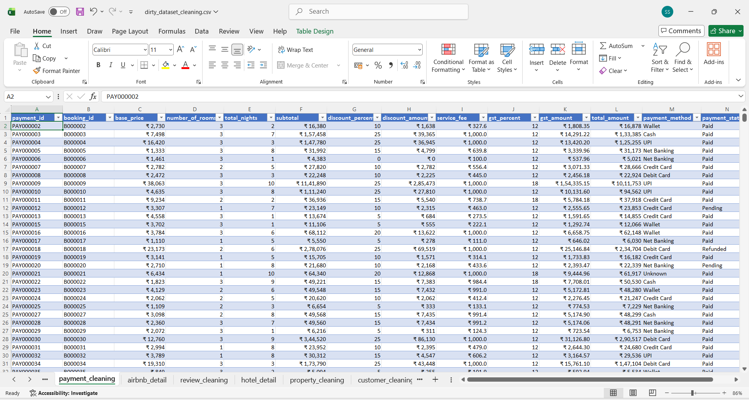Missing values were corrected using logical business rules where possible, or the row was removed where reconstruction was not reliable. Duplicate records were removed using Excel's Remove Duplicates feature, checked against each table's unique identifier (Booking ID, Customer ID, Property ID, Payment ID, Review ID) to avoid inflating booking or revenue totals.
Categorical fields — particularly Room Type and Booking Status — were standardised into fixed sets (Standard/Deluxe/Suite and Confirmed/Cancelled/Waiting) after trimming extra spaces and correcting inconsistent capitalisation, since Power BI would otherwise treat spelling variants as separate categories. All date columns (Booking, Check-in, Check-out, Payment, Review dates) were converted to a single consistent format, and numerical fields (nights, price, discount, tax) were checked against realistic business ranges.
The Payment, Customer, and Review tables received additional targeted checks — payment amount and status consistency, valid age and city values, and valid rating ranges — before a final validation pass confirmed the entire dataset was free of duplicates, blank key fields, and relationship inconsistencies prior to import into MySQL. Table 16.1 summarises the principal challenges encountered and the solutions applied.

Challenge | Solution Applied
Missing values | Corrected using logical rules or removed if unreconstructable.
Duplicate records | Removed using Excel's Remove Duplicates against key IDs.
Inconsistent categories (Room Type, Status) | Standardised into fixed category sets.
Extra spaces / inconsistent casing | Cleaned using Excel text functions.
Inconsistent date formats | Converted to a single standard date format.

Table 16.1: Key Data Cleaning Challenges and Solutions

17. EXCEL DASHBOARD DEVELOPMENT
Once the tables were cleaned, an intermediate dashboard was built in Excel using Pivot Tables, ahead of the SQL and Power BI stages. Its purpose was twofold: to give an early view of key metrics, and to validate the cleaned data — any residual inconsistency would surface as an unexpected extra row in a Pivot Table summary.
Pivot Tables summarised total revenue, bookings, and average booking value by city, property type, room type, and booking status, with linked Pivot Charts and basic slicers for filtering by property type or city. This dashboard mirrored the KPIs later built in Power BI and served as a cross-check: any mismatch between the two would prompt a review of the DAX measure or data model responsible.
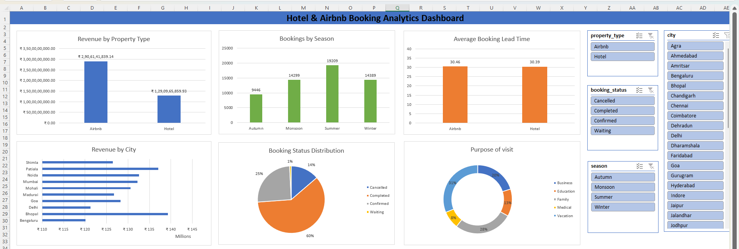

18. SQL DATABASE IMPLEMENTATION

The cleaned data was imported into a MySQL Workbench database containing seven tables — booking_dirty, customer_dirty, property_dirty, hotel_detail, airbnb_detail, payment_dirty, and review_dirty — preserving the relationships established in the Dataset Description chapter.
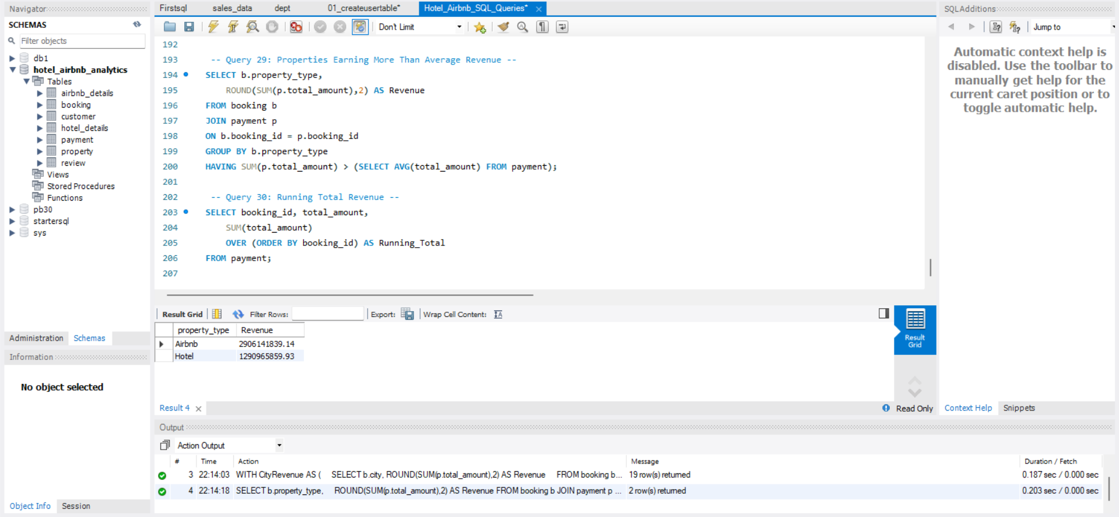
Data was loaded using the Table Data Import Wizard, after which each table was checked for correct row counts, column types, and absence of missing records. Validation queries then confirmed primary-key uniqueness and valid foreign-key references before analytical queries were run.
One notable issue was a UTF-8 Byte Order Mark in certain CSV files, which caused the first column name in a table to appear with an unexpected leading character; this was resolved by renaming the affected column after import. Implementing the data relationally in MySQL enabled efficient querying and integrated smoothly with the Power BI stage that followed.

19. SQL ANALYSIS
More than twenty analytical SQL queries were written against the MySQL database, each targeting one of the project's objectives across six areas. Revenue queries broke down total revenue by city, property type, room type, and booking status by joining Booking with Payment and Property. Booking queries examined monthly/seasonal counts, status distribution, and average stay length using date-based grouping on the Booking table.
Customer queries identified top revenue-contributing customers and their geographic distribution; property queries compared hotel versus Airbnb performance and ranked properties by revenue and rating. Payment queries identified the most-used payment methods and their revenue share, while review queries calculated average rating, rating distribution, and review volume, joined back to Booking for property- and room-level satisfaction analysis. Table 19.1 summarises this stage.

Activity | Status
Database created & data imported | Completed
Relationships & data validated | Completed
Revenue, Booking, Customer analysis | Completed
Property, Payment, Review analysis | Completed
20+ analytical SQL queries executed | Completed

Table 19.1: SQL Implementation Summary

20. POWER BI DATA MODELING
The seven cleaned tables were imported into Power BI Desktop using Get Data, and each was checked in Data view to confirm correct records, columns, and types. A relational model was then built in Model view using the same keys established in MySQL — Customer ID, Property ID, and Booking ID — with Booking as the central fact table connected to Customer, Property, Payment, and Review, and Property connected separately to Hotel Detail and Airbnb Detail.
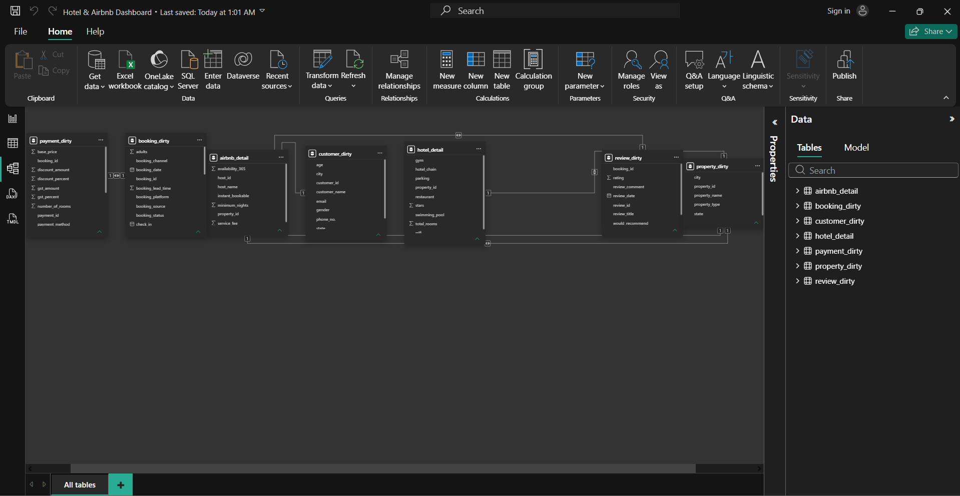Initial relationship creation failed for a small number of tables due to residual duplicate identifiers and data-type mismatches between joining columns; these were resolved by correcting the affected records and aligning column types, after which all relationships were established successfully and visuals began to filter and cross-highlight consistently.
This single, verified data model became the foundation for every visual, slicer, and DAX measure built in the remainder of this chapter set, ensuring that a filter selection made anywhere on the dashboard would propagate correctly to every connected chart and KPI card.

21. DAX MEASURES
Five DAX measures power the dashboard's KPI cards, each recalculating dynamically within the filter context set by the report's slicers rather than returning a fixed value. Table 21.1 lists each measure, its formula, and its purpose.

Measure | DAX Formula | Purpose
Total Revenue | SUM(payment_dirty[final_amount]) | Aggregates payment revenue under current filters.
Total Bookings | COUNTROWS(booking_dirty) | Counts reservations in the current context.
Total Customers | DISTINCTCOUNT(booking_dirty[customer_id]) | Counts unique customers, not transactions.
Average Rating | AVERAGE(review_dirty[customer_rating]) | Mean customer satisfaction score.
Avg. Stay Duration | AVERAGE(booking_dirty[total_nights]) | Mean nights booked per reservation.

Table 21.1: DAX Measures Summary

22. DASHBOARD DEVELOPMENT
The dashboard was designed around a simple, professional layout, a consistent blue colour theme, clear chart titles, and full interactivity. To avoid overcrowding, it was split into two pages: an Executive Overview for high-level KPIs, and a Customer & Property Insights page for more detailed analysis. Visuals were built directly on the relational model — KPI cards bound to the five DAX measures, followed by bar, line, and donut charts for each business dimension.
Slicers for City, Property Type, Season, and Booking Status were added and synchronised across both pages, so a filter selected on one page remains active on the other. Dedicated navigation buttons allow users to move between pages without relying on Power BI's default tabs, giving the report a polished, application-like feel suitable for direct business use.
Consistent spacing, aligned KPI cards, and legible axis labels and legends were maintained throughout, even after visuals were resized to fit the page layout — an attention to formatting intended to make the dashboard presentable in a business setting rather than resembling a rough analytical draft.

23. DASHBOARD EXPLANATION

23.1 Page 1 – Executive Overview
Five KPI cards — Total Revenue, Total Bookings, Total Customers, Average Rating, and Average Stay Duration — sit at the top of this page. Below them, Top 10 Cities by Revenue ranks the strongest markets, Revenue by Property Type compares Hotels against Airbnb, Monthly Revenue Trend shows seasonal fluctuation, and Booking Status Distribution shows the Confirmed/Cancelled/Waiting split.

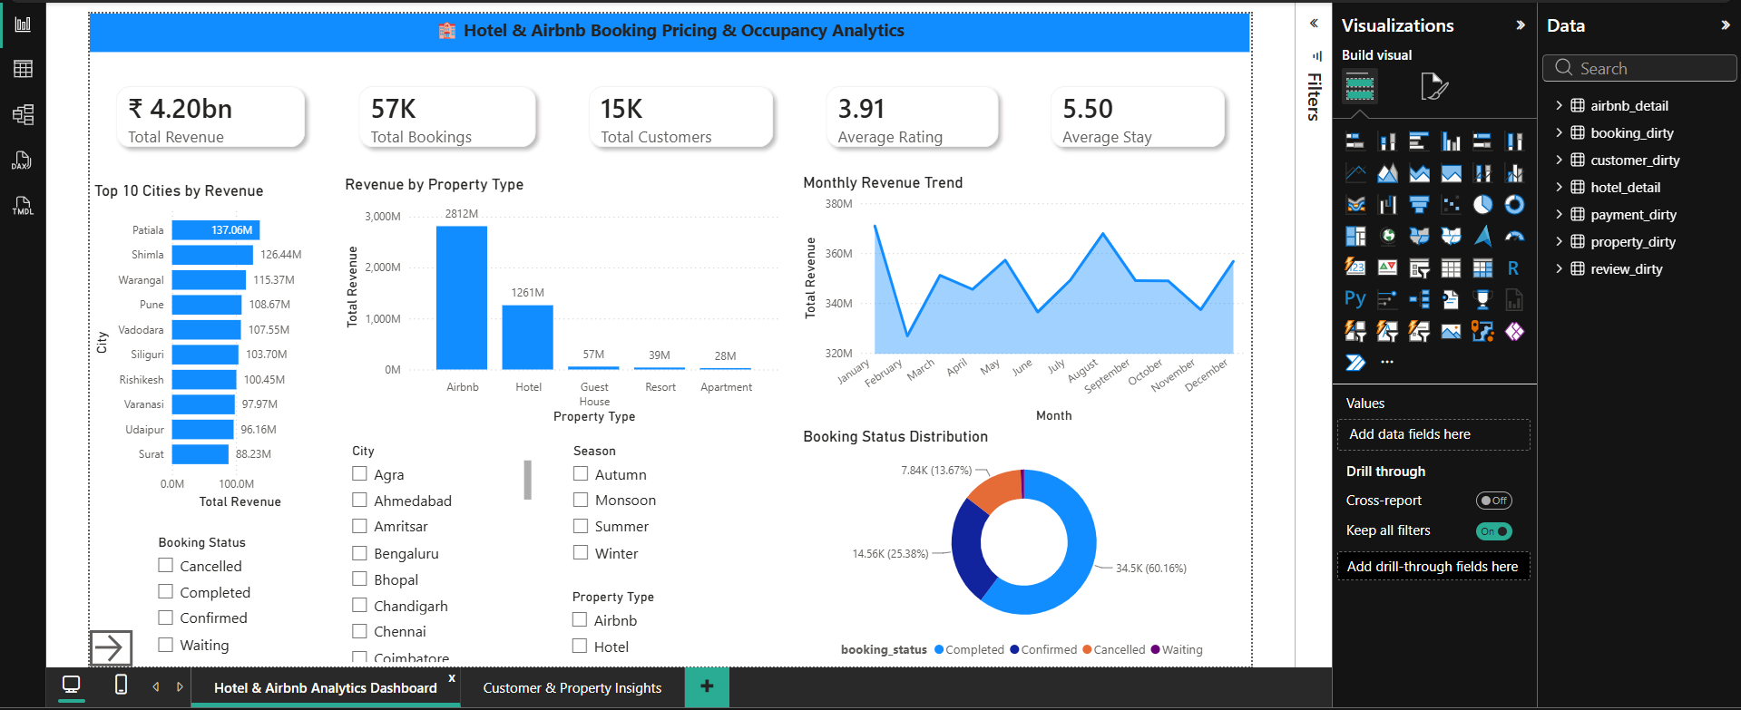

23.2 Page 2 – Customer & Property Insights
This page ranks Top Customers by Revenue, shows Payment Method Distribution, compares Total Revenue by Room Type, breaks down bookings by Purpose of Visit, shows Bookings by Season, and ranks the Most Preferred Room Types. Every visual on both pages shares the same City, Property Type, Season, and Booking Status slicers, so a single selection updates revenue, booking status, room preference, and rating simultaneously across the report.

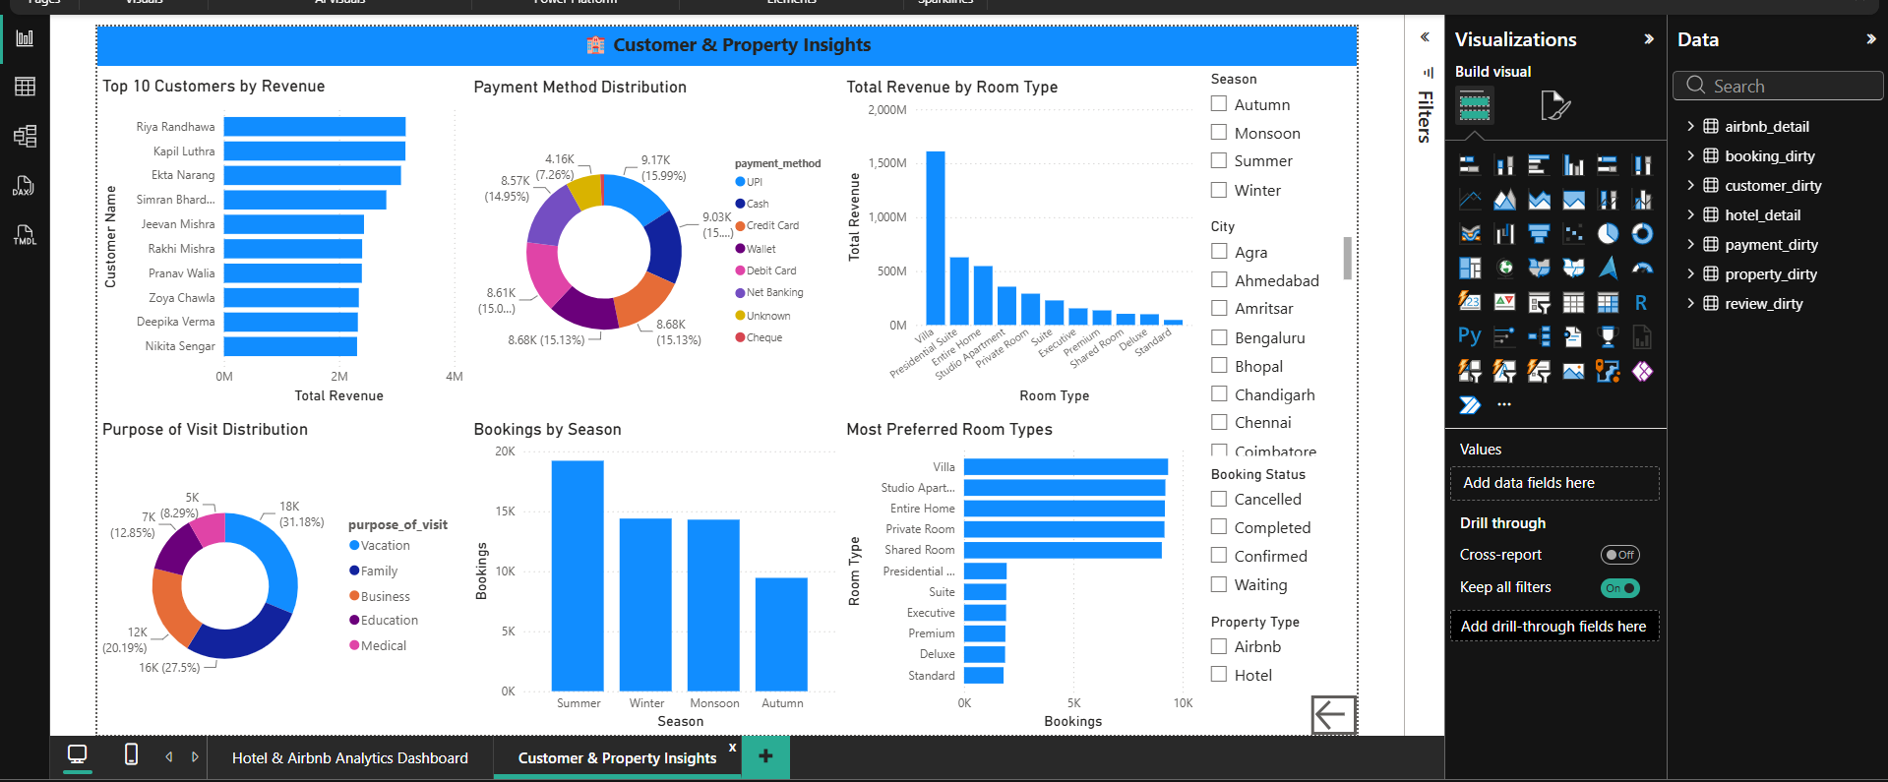

24. BUSINESS INSIGHTS
The combined SQL analysis and Power BI dashboard produced concrete insights beyond what manual inspection of raw data could reveal. Revenue is concentrated in a small number of cities and property types; booking volume rises and falls seasonally; hotels and Airbnb listings perform differently across markets; and certain room types are consistently preferred over others.
A meaningful share of bookings fall outside the Confirmed status, worth monitoring as an operational signal, while a relatively small group of high-value customers contributes disproportionately to revenue — a useful target for retention efforts. Customers also show clear payment-method preferences, and average review ratings, filterable by city, property, and room type, give an actionable, comparable measure of service quality. Table 24.1 consolidates these findings.

Insight Area | Key Finding
Revenue | A small set of cities and property types drive a disproportionate share of revenue.
Property Performance | Hotels and Airbnb listings show measurably different booking and revenue patterns.
Booking Trends | Booking volume fluctuates noticeably across months and seasons.
Room Preferences | Certain room categories are booked substantially more often than others.
Booking Status | A meaningful share of bookings are Cancelled or Waiting, not Confirmed.
Customer Behaviour | A relatively small group of customers contributes a large share of revenue.
Payment Preferences | Customers show a clear preference for specific payment methods.
Customer Satisfaction | Average ratings are filterable by city, property, and room type.

Table 24.1: Summary of Business Insights

25. CHALLENGES FACED AND SOLUTIONS
Viewed collectively, nearly every significant obstacle in this project traced back to a data-quality issue not yet fully resolved, whose effect only became visible in a later tool. Missing values, duplicates, and inconsistent categorical naming in Excel, if left uncorrected, would later surface as failed Power BI relationships or distorted SQL aggregates — reinforcing the value of thorough validation at the earliest stage.
A UTF-8 Byte Order Mark issue during MySQL import was not a data flaw but a file-encoding artefact, resolved by renaming the affected column. Similarly, Power BI relationship failures traced back to a small number of duplicate or blank identifiers and data-type mismatches, requiring a return to earlier cleaning decisions rather than a workaround within Power BI itself.
Once the data and relationships were stable, remaining challenges shifted to usability — avoiding an overcrowded single page, keeping slicers synchronised across both dashboard pages, and configuring intuitive navigation buttons — resolved through iterative layout revisions. Overall, the reliability of the final dashboard depended far more on the discipline applied during data preparation than on the visualisation tool itself.

26. SKILLS LEARNED
This project developed practical skills across the full BI workflow: data cleaning and validation in Excel (missing values, duplicates, standardisation, Pivot Tables); relational database design and SQL query writing in MySQL (joins, aggregation, referential integrity); data modelling, DAX, and interactive dashboard design in Power BI (slicers, navigation, formatting); and broader analytical skills in translating business objectives into specific queries and visuals, and diagnosing issues back to their root cause across tools.

27. CONCLUSION
This project demonstrates the complete lifecycle of a modern analytics solution applied to a real hospitality booking dataset. A raw dataset containing missing values, duplicates, and inconsistent categories was cleaned in Excel, structured and queried relationally in MySQL, and finally modelled and visualised in Power BI as a two-page interactive dashboard with KPI cards, charts, synchronised slicers, and navigation buttons.
The resulting insights — high-revenue cities, hotel-versus-Airbnb performance, seasonal demand, room preferences, payment behaviour, and customer satisfaction — confirm that the solution converts raw booking records into an actionable decision-support tool. Table 27.1 summarises the outcome of each project phase.

Phase | Tool | Outcome
Data Preparation | Microsoft Excel | Cleaned, validated dataset across all seven tables.
Database Implementation | MySQL Workbench | Relational database with verified relationships.
Data Analysis | SQL | 20+ queries generating business insights.
Dashboard Development | Power BI Desktop | Interactive two-page BI dashboard.

Table 27.1: Final Project Summary

Overall, the project reinforces that a business intelligence solution's value depends less on the sophistication of its final dashboard and more on the rigour applied at every earlier stage — accurate data preparation, sound relational design, and validated analytical querying.

28. FUTURE SCOPE
Future enhancements could include integrating the pipeline with a live booking system for real-time dashboard updates; applying machine learning for demand forecasting and dynamic pricing recommendations; using clustering for deeper customer segmentation and personalised recommendations; adapting the dashboard for mobile viewing; and migrating the database and Power BI dataset to a cloud environment for improved scalability and collaborative access.

29. REFERENCES
1. Microsoft Excel Documentation.
2. Microsoft Power BI Documentation.
3. Oracle MySQL Documentation.
4. Kimball, The Data Warehouse Toolkit.
5. Few, Information Dashboard Design.

